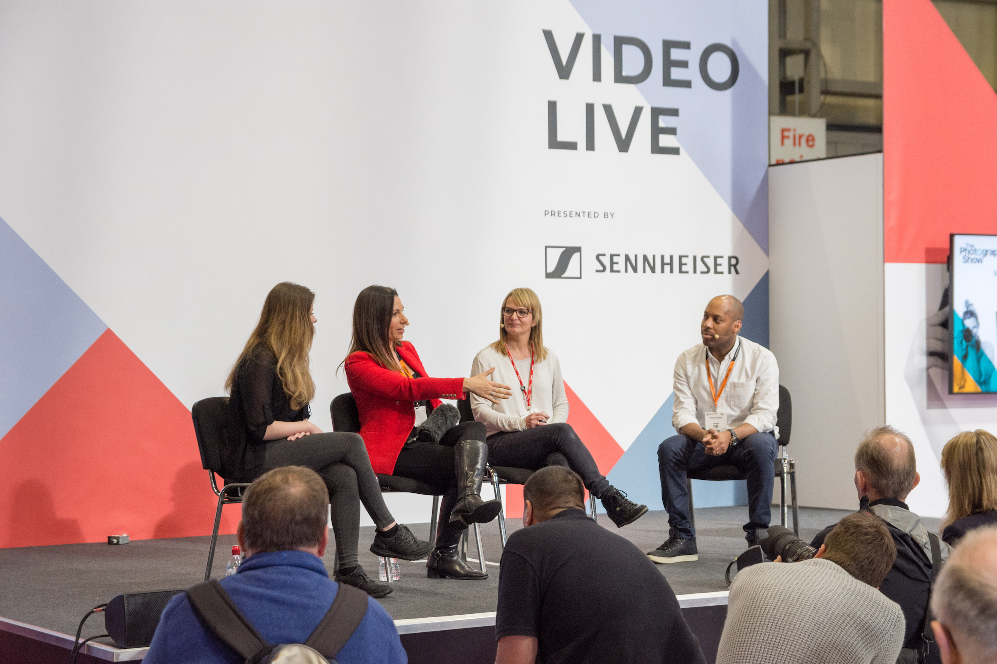

Sennheiser RETURNS TO THE 2020 VIDEO SHOW WITH FULL A4V PRODUCT LINE UP

Marlow/Birmingham, March 3, 2020 - Following on the success of last year’s Video Show, world-renowned audio specialist Sennheiser will be attending the 2020 show for the fourth year running. This year, the company will be showcasing its full range of wireless microphones for audio for video applications, including the award-winning XS Wireless Digital, AVX, and evolution wireless G4. On top of that, the company will have its latest line up of shotgun/on-camera mics, the MKE 400, MKE 440 stereo mic, MKE 600, MKH 416, and MKH 8000 series. Additionally, Sennheiser will be supporting Women Who Photo and Film campaign, championing the work of all talented individuals and encouraging more of them to join filmmaking and photography industries.

As well as product demonstrations on the Sennheiser stand A114, the company will be hosting a series of panels at the show to demonstrate how filmmakers can achieve better sound for better videos. Sennheiser’s sponsorship of the Video Live theatre, which hosts around 1000 visitors per day, has seen great success in the last few years. At this year’s show, sessions will run every hour, across all four days and will see some of the industry’s most prominent filmmakers talk about the importance of audio in their filmmaking. These include internet filmmaker Andy Burgess, who will talk about the importance of audio in storytelling; Tania Esteban, a specialist in wildlife filmmaking who has recently visited Papua New Guinea, Mexico and Japan; and two friends and filmmakers, Ryan Say, a director, videographer, drone pilot, video consultant and photographer, and videographer and commercial content creator, Dillon Osborne.

For those looking to get a more technical overview of audio equipment for video, Sennheiser will be hosting sessions on its Sennheiser Sound Academy Stage, where the company’s John McGregor will cover topics such as ‘Microphone Basics’ and ‘Going Wireless’ during 20-minute sessions throughout the day.

Both the Video Live Stage and Sennheiser Sound Academy Stage will appeal to professional filmmakers and budding amateurs alike, who will be able to enjoy four days of talks from industry experts on the vital ingredients for recording audio, whether you’re shooting interviews, weddings, documentaries, web content or corporate marketing materials.

As this year marks Sennheiser’s 75th Anniversary, the company will be offering incredible savings on selected wired microphones, wireless systems and headphones throughout the year. In many instances, discounts will approach 40%, 50% or even more off the MSRP, with regular updates on its new product of the month being posted on the website sennheiser.com/75years

Sennheiser Sound Academy and Video Live Stage presentations will be available on the following days and times below, this is subject to a change. Visit The Photography Show website nearer to the show for full timetable and schedules.

Saturday, March 14th – Day 1

Video Live Stage
1500-1530 The importance of sound in visual storytelling Andy Burgess

Sennheiser Sound Academy Stage
John McGregor cover topics such as ‘Microphone Basics’ and ‘Going Wireless’ during 20-minute sessions throughout the day.

Sunday, March 15th – Day 2

Video Live Stage
1500-1530 The importance of sound in visual storytelling Andy Burgess

Sennheiser Sound Academy Stage
John McGregor cover topics such as ‘Microphone Basics’ and ‘Going Wireless’ during 20-minute sessions throughout the day.

Monday, March 16th – Day 3

Video Live Stage
1600-1630 The workflows of a wildlife filmmaker
Tania walks through her planning processes, technical setups and workflows involved with shooting wildlife around the world, including examples from recent trips to Japan, Mexico and Papua New Guinea.

Sennheiser Sound Academy Stage
John McGregor cover topics such as ‘Microphone Basics’ and ‘Going Wireless’ during 20-minute sessions throughout the day.

Tuesday, March 17th – Day 4

Video Live Stage
1100-1130 Great audio will make your video Dillon Osborne and Ryan Say
Join Sennheiser's experts for an in-depth look at sound techniques for video. Great sound in your films can make all the difference and this session will leave you full of ideas to apply to yours.

Sennheiser Sound Academy Stage
John McGregor cover topics such as ‘Microphone Basics’ and ‘Going Wireless’ during 20-minute sessions throughout the day.

Visit Sennheiser on Stand A114 at the Video Show (co-hosted alongside the Photography Show), which takes place from March 14-17 at Birmingham’s NEC. Visitors can use discount code SENNTPS20 to receive 20% off the entry ticket fee.

about Sennheiser
Founded in 1945, Sennheiser is celebrating its 75th anniversary this year. Shaping the future of audio and creating unique sound experiences for customers – this aim unites Sennheiser employees and partners worldwide. The independent family company, which is managed in the third generation by Dr. Andreas Sennheiser and Daniel Sennheiser, is today one of the world’s leading manufacturers of headphones, loudspeakers, microphones and wireless transmission systems. In 2018, the Sennheiser Group generated turnover totaling €710.7 million. www.sennheiser.com

Local Press Contacts

Sarah James Maik Robbe
sarahj@gasolinemedia.com maik.robbe@sennheiser.com
+44 (0) 1483 223333 +44 (0) 7393 462484

Guest speaker biographies:

Andy Burgess
Andy is an Internet filmmaker, who found an audience on Snapchat and Instagram stories, in 2017 when he was living in New York, and quickly became one of the most recognised creators on the platform and became a 2018 Shorty Award finalist for Snapchatter of the Year.
Now based in East London Andy’s focus has moved to YouTube where he is creating visually beautiful explainer videos about communities and cultures around the world that peak his curiosity and shares their stories with his audience.
Andy also spends a lot of time talking about the creative process to young creators and works with brands like Joby, Red Bull, Boosted Board and Samsung, creating exciting and engaging social content.

Dillon Osborne
Dillon is a freelance creative based in Belfast, specialising with brands to bring their stories and ideas to life through photography, film and design. An early adopter of video on Instagram stories and IGTV, Dillon has used the platform to create a daily vlog which explores fast short form content focused around photo and film, and opened his eyes to new ways of creating content. @diltakesphotos

Ryan Say
Creating video is Ryan's life.
He has travelled across the globe producing video series' and corporate films for top level video marketers and global coaching companies as well creating highly effective corporate videos for businesses across a range of sectors - from nails to nursing, banks to brake fluid.
http://www.instagram.com/ryansaycreates

Tania Esteban
A graduate from the University of Leeds with a 1st class Zoology degree, Tania recently completed her MA in Wildlife Filmmaking in partnership with the BBC, where her final film titled “A Lions Tale” was nominated for a student BAFTA award.
Tania gained exclusive access to Meru National Park and the largest ivory burn in Kenyan history. Working with Will Travers and the Born Free Foundation, Tania filmed the human-lion conflict in the park - a story that inspired her as a child.
Working as a bilingual Zoologist, wildlife camerawomen and researcher has led Tania to learn all areas of documentary filmmaking including editing, producing and directing. Tania has worked on blue-chip pure natural history documentaries at the BBC as well as at several indies and is also a fully qualified CAA drone pilot.
www.treproductions.co.uk#
http://vivida.co.uk

